

ASSET VERIFICATION AND RECORDING TOOL KIT


Plot 31, Bukoto Street
P.O Box 7657, Kampala, Uganda
+256 (0) 39 2000216/0772525235
email: cpa@cpa.ug

www.cpa.com

August to September 2026

VERIFICATION DETAILS

NAME OF THE REGION: | CENTRAL REGION
SUB-REGION: | BUGANDA
Name of Local Government | MUBENDE DISTRICT
VERIFIER PARTICULARS
Full name | KATO CHARLES
Contact/ email and Telephone | 0755790124 &  katoc560@gmail.com
Supervisor/ Sub team leader
Name | Prof: MBONIGABA DEPAUL
Contact | 0788483159
Date of submission | 31/08/2026

HEALTH CENTRES
INFORMANT INTERVIEW/DISCUSSION GUIDE (INCHARGE OR RESPONSIBLE PERSON)

Name of Health Centre: BUTAWATA HC III

1a | Does the Facility have a record of all assets provided under UgIFT.  (Obtain a record and verify if it has the costs and numbers supplied | No, the facility misplaced the file
1b | If not ask how many were supplied and when.

2 | How does this facility Maintain (repair/service/replace) the assets provided under Ugift

The facility has a dedicated budget for repairs/ replacement especially for those items on the NMS credit line, and at times they receive some support from mubende RRH

3 | Does the facility take regular record about functionality/ or breakdown of the assets provided? | No, the facility did not provide a list of the items available

The facility did not have an asset register or a functionality list for equipment in place.

4 | How has the UgIFT support helped in service delivery in the area, any issues, challenges and any recommendations for better program implementation.

The incharge expressed gratitude to the UGIFT program for equipping the health facility with the necessary equipment which eased their mandate as health workers. She also complained about the quality of office chairs and tables that were delivered to her facility that lasted only 2 weeks and were spoilt.
She recommended that CME, on equipment use should be arranged for health workers after delivery of these items, and that they should be involved in the procurement of the equipment to avoid over supply which causes storage problems

PROCEED TO VERIFICATION AFTER THIS DISCUSSION

Health centre checklist

NAME OF LG: MUBENDE DISTRICT NAME OF HEALTH FACILITY: BUTAWATAHC III

Equipment/ Item | Department | Asset Number | Item  Description | Life in Months | Tag Number (engrave no.) | Date Of Purchase | Date Placed in Service | Recoverable cost | Cost | Acc Dep Cost | Net Book Value | Ytd Deprn | Equipment status | Remarks
B.P. Machine, Digital | health |  | sinoheart, model BA-801 sionocare bp machine |  | Not engraved |  | 8/03/2024 |  |  |  |  |  | 2 functional and one in the store
 | Health |  | Sinocare bp machine, Model AES-U111 |  | Not engraved |  | 8/03/2024 |  |  |  |  |  | functional
B.P. Machine (Aneroid wall mounted) | health |  | BP machine (aneroid wall mounted, Navy blue in colour |  | Not engraved |  | 8/03/2024 |  |  |  |  |  | Not functional
 | health |  | BP machine (aneroid wall mounted, Navy blue in colour |  | Not engraved |  | 8/03/2024 |  |  |  |  |  | Not functional
 |  |  |  |  |  |  | 8/03/2024
Autoclave 20 Liters., Duo Operated
 | health |  | Autoclave, external heated, 20liters |  | Not engraved |  | 8/03/2024 |  |  |  |  |  | functional
Bowl, Kick | Health |  | 1 bowl kick |  | Not engraved |  | 8/03/2024 |  |  |  |  |  | functional
 |  |  |  |  |  |  | 8/03/2024
Bowl Stand
 | health |  | Stainless steel movable |  |  |  | 8/03/2024 |  |  |  |  |  | functional
 | Health |  | Stainless steel movable |  | Not engraved |  | 8/03/2024 |  |  |  |  |  | functional
Counting chamber Neubauer- Improved | Health |  | 1 Counting chambers, with droppers |  | Not engraved |  | 8/03/2024 |  |  |  |  |  | Not functional
 | health |  | 1 Counting Rectangular shaped apparatus with droppers |  | Not engraved |  | 8/03/2024 |  |  |  |  |  | Not functional
 | Health |  | 1 Counting Rectangular shaped apparatus with droppers |  |  |  | 8/03/2024 |  |  |  |  |  | Not functional
Cupboard Steel, Lockable | Health |  |  |  |  |  | 8/03/2024
 | Health |  | 1 cupboard steel with transparent glass, lockable (grey) |  | Not engraved |  | 8/03/2024 |  |  |  |  |  | Functional
 | Health |  | 1 cupboard steel with transparent glass, lockable (grey) |  | Not engraved |  | 8/03/2024 |  |  |  |  |  | functional
Drip Stand |  |  |  |  |  |  | 8/03/2024
 | Health |  | 1 Drip stand, stainless steel attached to the beds |  | Not engraved |  | 8/03/2024 |  |  |  |  |  | functional
 | Health |  | 1 Drip stand, MK-ISO, SN MM220210C01 |  | Not engraved |  | 8/03/2024 |  |  |  |  |  | functional
 | Health |  | 1 Drip stand, MK-ISO, SN MM220210C01 |  | Not engraved |  | 8/03/2024 |  |  |  |  |  | functional
 | Health |  | 1 1Drip stand, MK-ISO, SN MM220210C01 |  | Not engraved |  | 8/03/2024 |  |  |  |  |  | functional
 | Health |  | 1 Drip stand, MK-ISO, SN MM220210C01 |  | Not engraved |  | 8/03/2024 |  |  |  |  |  | functional
 | Health |  | 1 1Drip stand, MK-ISO, SN MM220210C01 |  | Not engraved |  | 8/03/2024 |  |  |  |  |  | functional
 | Health |  | 1 Drip stand, MK-ISO, SN MM220210C01 |  | Not engraved |  | 8/03/2024 |  |  |  |  |  | functional
 | Health |  | 1 Drip stand, MK-ISO, SN MM220210C01 |  | Not engraved |  | 8/03/2024 |  |  |  |  |  | functional
ESR Stand
 | health |  | 1 ESR was available with sedimentation tubes |  | Not engraved |  | 8/03/2024 |  |  |  |  |  | functional
Examination Couch
 | Health |  | Examination couch metallic with a mattress |  | Not engraved |  | 8/03/2024 |  |  |  |  |  | functional
 | Health |  | Examination couch metallic with a mattress |  | Not engraved |  | 8/03/2024 |  |  |  |  |  | functional
Examination light,LED
 | health |  | LED examination light |  | Not engraved |  | 8/03/2024 |  |  |  |  |  | functional
 | Health |  | LED examination light |  | Not engraved |  | 8/03/2024 |  |  |  |  |  | functional
Glucometer
 | health |  | A Yuwell glucometer, SN: B25070000104 |  | NOT ENGRAVED |  | 8/03/2024 |  |  |  |  |  | Not functional
 | health |  | A Yuwell glucometer, SN: B25070000104 |  | NOT ENGRAVED |  | 8/03/2024 |  |  |  |  |  | Not functional
Haemoglobin Meter, Digital
 | Health |  | Haemoglobin Meter, Digital |  | Not engraved |  | 8/03/2024 |  |  |  |  |  | Not functional
 | Health |  | Haemoglobin Meter, Digital |  | Not engraved |  | 8/03/2024 |  |  |  |  |  | Not functional
Height Meter
 | Health |  | 1 height meter |  | Not engraved |  | 8/03/2024 |  |  |  |  |  | Functional
Instrument Trolley |  |  |  |  |  |  | 8/03/2024
 | health |  | 1 instrument trolly |  | Not engraved |  | 8/03/2024 |  |  |  |  |  | Functional
 | health |  | 1 instrument trolly |  | Not engraved |  | 8/03/2024 |  |  |  |  |  | Functional
Microscope Binocular
 | health |  | 1 microscope binocular, |  | Not engraved |  | 8/03/2024 |  |  |  |  |  | Functional
Otoscope
 | health |  | 1 otoscope, sn: 97412531595 |  | Not engraved |  | 8/03/2024 |  |  |  |  |  | Functional
Patient Screen
 | health |  | 1 patient screen, super care model TS-19 |  | Not engraved |  | 8/03/2024 |  |  |  |  |  | Not functional
 | health |  | 1 patient screen, metallic, blue in colour, movable |  | Not engraved |  | 8/03/2024 |  |  |  |  |  | Not functional
 | health |  | 1 patient screen |  | Not engraved |  | 8/03/2024 |  |  |  |  |  | Not functional
 | health |  | 1 patient screen, metallic, blue in colour, movable |  | Not engraved |  | 8/03/2024 |  |  |  |  |  | Not functional
Patient Trolley
 | Health |  | 1 patient trolley of casp |  |  |  | 8/03/2024 |  |  |  |  |  | functional
Refrigerator, Basic
 | Health |  | 1 refrigerator basic, Hisense brand | 18 months | Not engraved |  | 8/03/2024 |  |  |  |  |  | Not functional
Stethoscope
 | Health |  | stethoscope |  | Not engraved |  | 8/03/2024 |  |  |  |  |  | Not functional
 | Health |  | stethoscope |  | Not engraved |  | 8/03/2024 |  |  |  |  |  | Not functional
 | Health |  | stethoscope |  | Not engraved |  | 8/03/2024 |  |  |  |  |  | Not functional
 | Health |  | stethoscope |  | Not engraved |  | 8/03/2024 |  |  |  |  |  | Functional
Stopwatch
 | Health |  | 1 stopwatch |  | Not engraved |  | 8/03/2024 |  |  |  |  |  | Functional
Stretcher
 | Health |  | 1 stretcher, movable |  | Not engraved |  | 8/03/2024 |  |  |  |  |  | Not functional
Stove, Gas | health |  | STOVE GAS |  | Not engraved |  | 8/03/2024 |  |  |  |  |  | Not Functional
Weighing Scale with Height Meter, Adult
 | Health |  | 1 weighing scale with height measure |  | Not engraved |  | 8/03/2024 |  |  |  |  |  | functional
 | health |  | 1 weighing scale with height measure |  | Not engraved |  | 8/03/2024 |  |  |  |  |  | Functional
Weighing Scale, Infant
 | Health |  | Hanging weighing scale foe infants, SN: BS-50 |  | NOT ENGRAVED |  | 8/03/2024 |  |  |  |  |  | NOT FUNCTIONAL
 | Health |  | Hanging weighing scale foe infants, SN: BS-50 |  | Not engraved |  | 8/03/2024 |  |  |  |  |  | functional
Weighing Scale, Toddler
 | Health |  | 1 weighing scale toddler, KUANYI MODEL, BS-50 |  | Not engraved |  | 8/03/2024 |  |  |  |  |  | Functional in the maternity ward
 | Health |  | 1 weighing scale toddler, KUANYI MODEL, BS-50 |  | Not engraved |  | 8/03/2024 |  |  |  |  |  | Functional in the maternity ward
Wheelchair
 | Health |  | 1 wheelchair |  | Not engraved |  | 8/03/2024 |  |  |  |  |  | Not functional | Wheelchair was spoilt
Audio Visual Equipment
 | HEALTH |  | 1 television, flat screen |  | Not engraved |  | 8/03/2024 |  |  |  |  |  | functional
Medical Waste Bin
 | Health |  | Stainless steel bins |  | Not engraved |  | 8/03/2024 |  |  |  |  |  | Functional
 | Health |  | Stainless steel bins |  | Not engraved |  | 8/03/2024 |  |  |  |  |  | Functional
 | Health |  | Medical waste bins |  | Not engraved |  | 8/03/2024 |  |  |  |  |  | Functional
 | Health |  | Medical waste bins |  | Not engraved |  | 8/03/2024 |  |  |  |  |  | Functional
 | Health |  | Medical waste bins |  | Not engraved |  | 8/03/2024 |  |  |  |  |  | Functional
 | Health |  | Medical waste bins |  | Not engraved |  | 8/03/2024 |  |  |  |  |  | functional
Wall Clock |  |  |  |  |  |  | 8/03/2024
 | Health |  | Wall clock |  | Not engraved |  | 8/03/2024 |  |  |  |  |  | functional
 | Health |  | Wall clock |  | Not engraved |  | 8/03/2024 |  |  |  |  |  | functional
 | Health |  | Wall clock |  | Not engraved |  | 8/03/2024 |  |  |  |  |  | functional
 | Health |  | Wall clock |  | Not engraved |  | 8/03/2024 |  |  |  |  |  | Functional
Diagnostic Equipment Set for MCH
 | Health | SL304 | Full diagnostic set consisting of all equipment (full medical package) |  | NOT ENGRAVED |  | 8/03/2024 |  |  |  |  |  | NOT FUNCTIONAL
 | Health | SL304 | Full diagnostic set consisting of all equipment (full medical package) |  | NOT ENGRAVED |  | 8/03/2024 |  |  |  |  |  | NOT FUNCTIONAL
Diagnostic Equipment Set for OPD
 | Health | SL304 | 1 diagnostic equipment set OPD |  | Not engraved |  | 8/03/2024 |  |  |  |  |  | Not functional
 | Health | SL304 | 1 diagnostic equipment set OPD |  | Not engraved |  | 8/03/2024 |  |  |  |  |  | Not functional
Glassware Set, Laboratory, Basic
 | Health |  | 1 glass ware set` |  | Not engraved |  | 8/03/2024 |  |  |  |  |  | Functional
 | Health |  | 1 glass ware set` |  | Not engraved |  | 8/03/2024 |  |  |  |  |  | Functional
Hollow Ware Set, Treatment | Health |  | 1 hollow ware set, full set |  | Not engraved |  | 8/03/2024 |  |  |  |  |  | Not functional
 | Health | SL304 | 1 hollow ware set, full set |  | Not engraved |  | 8/03/2024 |  |  |  |  |  | Not functional
Instrument Set, Dressing | Health | SL304 | 1 Set consists of forceps, scissors, bowls, lotion, kidney, instrument container s/s with cover |  | Not engraved |  | 8/03/2024 |  |  |  |  |  | Not functional
 | Health | SL304 | 1 Set consists of forceps, scissors, bowls, lotion, kidney, instrument container s/s with cover. |  | Not engraved |  | 8/03/2024 |  |  |  |  |  | Functional
Instrument Set, Basic ENT
 | Health |  | Instrument set basic ENT |  | Not engraved |  | 8/03/2024 |  |  |  |  |  | Functional
 | Health |  | Instrument set basic ENT |  | Not engraved |  | 8/03/2024 |  |  |  |  |  | Functional
 | Health |  | Instrument set basic ENT |  | Not engraved |  | 8/03/2024 |  |  |  |  |  | Functional
Instrument Set, Suture
Pulse Oximeter, Hand held
 | Health |  | 1 Pulse oximeter, handheld |  | Not engraved |  | 8/03/2024 |  |  |  |  |  | Functional
 | Health |  | 1 Pulse oximeter, handheld |  | Not engraved |  | 8/03/2024 |  |  |  |  |  | Not functional
Bed, Adult Patient with Mattress | Health |  | Adult beds with metallic mattresses, model B11 batch no 20220542 |  | Not engraved |  | 8/03/2024 |  |  |  |  |  | functional
 | Health |  | Adult beds with metallic mattresses, model B11 batch no 20220542 |  | Not engraved |  | 8/03/2024 |  |  |  |  |  | Functional
 | Health |  | Adult beds with metallic mattresses, model B11 batch no 20220542 |  | Not engraved |  | 8/03/2024 |  |  |  |  |  | Functional
 | Health |  | Adult beds with metallic mattresses, model B11 batch no 20220542 |  |  |  | 8/03/2024 |  |  |  |  |  | Functional
 | Health |  | Adult beds with metallic mattresses, model B11 batch no 20220542 |  | Not engraved |  | 8/03/2024 |  |  |  |  |  | Functional
 | Health |  | Adult beds with metallic mattresses, model B11 batch no 20220542 |  | Not engraved |  | 8/03/2024 |  |  |  |  |  | Functional
 | Health |  | Adult beds with metallic mattresses, model B11 batch no 20220542 |  | Not engraved |  | 8/03/2024 |  |  |  |  |  | Functional
 | Health |  | Adult beds with metallic mattresses, model B11 batch no 20220542 |  | Not engraved |  | 8/03/2024 |  |  |  |  |  | Functional
 | Health |  | Adult beds with metallic mattresses, model B11 batch no 20220542 |  | Not engraved |  | 8/03/2024 |  |  |  |  |  | Functional
 | Health |  | Adult beds with metallic mattresses, model B11 batch no 20220542 |  | Not engraved |  | 8/03/2024 |  |  |  |  |  | Functional
Bed, Pediatric Patient, With Mattress
 | Health |  | Pediatric beds with metallic mattresses |  | Not engraved |  | 8/03/2024 |  |  |  |  |  | Functional
 | Health |  | pediatrics beds with mattresses metallic |  | Not engraved |  | 8/03/2024 |  |  |  |  |  | Functional
 | Health |  | pediatrics beds with mattresses metallic |  | Not engraved |  | 8/03/2024 |  |  |  |  |  | Functional
 | Health |  | pediatric beds with mattresses metallic |  | Not engraved |  | 8/03/2024 |  |  |  |  |  | Functional
 | Health |  | Pediatric beds with metallic mattresses |  | Not engraved |  | 8/03/2024 |  |  |  |  |  | Functional
Bedside Locker
 | health |  | Metallic bedside lockers, steel |  | Not engraved |  | 8/03/2024 |  |  |  |  |  | functional
 | Health |  | Metallic bedside lockers, steel |  | Not engraved |  | 8/03/2024 |  |  |  |  |  | Functional
 | Health |  | Metallic bedside lockers, steel |  | Not engraved |  | 8/03/2024 |  |  |  |  |  | Functional
 | health |  | Metallic bedside lockers, steel |  | Not engraved |  | 8/03/2024 |  |  |  |  |  | functional
 | Health |  | Metallic bedside lockers, steel |  | Not engraved |  | 8/03/2024 |  |  |  |  |  | Functional
 | health |  | Metallic bedside lockers, steel |  | Not engraved |  | 8/03/2024 |  |  |  |  |  | functional
 | Health |  | Metallic bedside lockers, steel |  | Not engraved |  | 8/03/2024 |  |  |  |  |  | Functional
 | health |  | Metallic bedside lockers, steel |  | Not engraved |  | 8/03/2024 |  |  |  |  |  | functional
 | Health |  | Metallic bedside lockers, steel |  | Not engraved |  | 8/03/2024 |  |  |  |  |  | Functional
 | health |  | Metallic bedside lockers, steel |  | Not engraved |  | 8/03/2024 |  |  |  |  |  | functional
Cupboard, Instrument | health |  | 1 cupboard steel lockable |  | Not engraved |  | 8/03/2024 |  |  |  |  |  | functional
 |  |  | 1 cupboard steel lockable |  | Not engraved |  | 8/03/2024 |  |  |  |  |  | functional
Delivery Bed, Hydraulic Manual | health |  | 1 Delivery bed manual hydraulic |  | Not engraved |  | 8/03/2024 |  |  |  |  |  | Functional
 | health |  | 1 Delivery bed manual hydraulic |  | Not engraved |  | 8/03/2024 |  |  |  |  |  | functional
Oxygen Therapy Apparatus, Minimum 45L cylinder | Health |  | 1 Oxygen cylinders of 49,8L 2, oxygen regulators (2), humidifier bottles (2) |  | Not engraved |  | 8/03/2024 |  |  |  |  |  | Not functional
 |  |  | 1 Oxygen cylinders of 49,8L 2, oxygen regulators (2), humidifier bottles (2) |  | Not engraved |  | 8/03/2024 |  |  |  |  |  | Not functional
Resuscitator Manual, Infant, with all Mask sizes
 | Health |  | 1 resuscitator manual |  | Not engraved |  | 8/03/2024 |  |  |  |  |  | Not functional
 | Health |  | 1 resuscitator manual |  | Not engraved |  | 8/03/2024 |  |  |  |  |  | Not functional
Resuscitator Manual, Adult, with all mask sizes
 | Health |  | 1 resuscitator manual, adult |  | Not engraved |  | 8/03/2024 |  |  |  |  |  | functional
 | Health |  | 1 resuscitator manual, adult |  | Not engraved |  | 8/03/2024 |  |  |  |  |  | Not functional | In the store
Suction Apparatus, (Electric)
 | Health |  | 1 suction apparatus, electric |  | Not engraved |  | 8/03/2024 |  |  |  |  |  | Not functional
 | Health |  | 1 suction apparatus, electric |  | Not engraved |  | 8/03/2024 |  |  |  |  |  | Not functional
Nebulizer, Ultrasonic
 | Health |  | 1 nebulizer ultrasonic |  | Not engraved |  | 8/03/2024 |  |  |  |  |  | Not functional
Oxygen Concentrator, Duo Flow
 | Health |  | 1 Oxygen concentrator |  | not |  | 8/03/2024 |  |  |  |  |  | functional
 | Health |  | 1 Oxygen concentrator |  | not |  | 8/03/2024 |  |  |  |  |  | functional
 | Health |  | 1Oxygen concentrator |  | not |  | 8/03/2024 |  |  |  |  |  | functional
 | Health |  | 1Oxygen concentrator |  | not |  | 8/03/2024 |  |  |  |  |  | Not functional | Machine no longer use it over heats
Bench
 | Health |  | 1 metallic vanished bench |  |  |  | 8/03/2024 |  |  |  |  |  | functional
 | Health |  | 1 metallic vanished bench |  |  |  | 8/03/2024 |  |  |  |  |  | functional
 | Health |  | 1 metallic vanished bench |  |  |  | 8/03/2024 |  |  |  |  |  | functional
 | Health |  | 1 metallic vanished bench |  | Not engraved |  | 8/03/2024 |  |  |  |  |  | functional
Disinfection Buckets
 | Health |  | 1 disinfection bucket |  | Not engraved |  | 8/03/2024 |  |  |  |  |  | functional
 | Health |  | 1 disinfection bucket |  | Not engraved |  | 8/03/2024 |  |  |  |  |  | functional
 | Health |  | 1 disinfection bucket |  | Not engraved |  | 8/03/2024 |  |  |  |  |  | functional
 | Health |  | 1 disinfection bucket |  | Not engraved |  | 8/03/2024 |  |  |  |  |  | functional
 | Health |  | 1 disinfection bucket |  | Not engraved |  | 8/03/2024 |  |  |  |  |  | functional
 | Health |  | 1 disinfection bucket |  | Not engraved |  | 8/03/2024 |  |  |  |  |  | functional
Baby Cot
 | Health |  | 1 baby cot |  | Not engraved |  | 8/03/2024 |  |  |  |  |  | functional
 | Health |  | 1 baby cot |  | Not engraved |  | 8/03/2024 |  |  |  |  |  | functional
 | Health |  | 1 baby cot |  | Not engraved |  | 8/03/2024 |  |  |  |  |  | functional
 | Health |  | 1 baby cot |  | Not engraved |  | 8/03/2024 |  |  |  |  |  | Not functional
 | Health |  | 1 baby cot |  | Not engraved |  | 8/03/2024 |  |  |  |  |  | Not functional
Diagnostic Equipment Set for Ward
 | health |  | 1 Set consists of:  Depressor, tongue, metal, hammer, percussion, reflex test, solid rubber head, ophthalmoscope, aneroid cuffs, stethoscope, tape, measure, cloth, thermometers, tuning forks, proctoscope, and syringes |  | Not engraved |  | 8/03/2024 |  |  |  |  |  | Functional
 | health |  | 1 Set consists of:  Depressor, tongue, metal, hammer, percussion, reflex test, solid rubber head, ophthalmoscope, aneroid cuffs, stethoscope, tape, measure, cloth, thermometers, tuning forks, proctoscope, and syringes |  | Not engraved |  | 8/03/2024 |  |  |  |  |  | Not Functional
 | health |  | 1 Set consists of:  Depressor, tongue, metal, hammer, percussion, reflex test, solid rubber head, ophthalmoscope, aneroid cuffs, stethoscope, tape, measure, cloth, thermometers, tuning forks, proctoscope, and syringes |  | Not engraved |  | 8/03/2024 |  |  |  |  |  | Not Functional
Hollow Ware Set, Ward
 | Health |  | 1 hollow ware set consisting of a bed pan s/s with lid, bowl, urinal, lotions, forceps, instrument trays, jug measuring 1 litre, and kidney dishes |  | Not engraved |  | 8/03/2024 |  |  |  |  |  | Not functional
 | Health |  | 1 hollow ware set consisting of a bed pan s/s with lid, bowl, urinal, lotions, forceps, instrument trays, jug measuring 1 litre, and kidney dishes |  | Not engraved |  | 8/03/2024 |  |  |  |  |  | Not functional
 | Health |  | 1 hollow ware set consisting of a bed pan s/s with lid, bowl, urinal, lotions, forceps, instrument trays, jug measuring 1 litre, and kidney dishes |  | Not engraved |  | 8/03/2024 |  |  |  |  |  | Not functional
Instrument Set, Delivery | Health |  | 1 set consisting of forceps, sponge holding, needle holder, scissors, speculum, bowls, kidney dish, and instrument container |  | Not engraved |  | 8/03/2024 |  |  |  |  |  | functional
 | Health |  | 1 set consisting of forceps, sponge holding, needle holder, scissors, speculum, bowls, kidney dish, and instrument container |  | Not engraved |  | 8/03/2024 |  |  |  |  |  | functional
 | Health |  | 1 set consisting of forceps, sponge holding, needle holder, scissors, speculum, bowls, kidney dish, and instrument container |  | Not engraved |  | 8/03/2024 |  |  |  |  |  | functional
Instrument Set, Stitch Removing
 | Health |  | 1 set, stitch removing consisting of forceps, sponge holding, scissors, bowls, lotion, and instrument containers |  | Not engraved |  | 8/03/2024 |  |  |  |  |  | functional
 | Health |  | 1 set, stitch removing consisting of forceps, sponge holding, scissors, bowls, lotion, and instrument containers |  | Not engraved |  | 8/03/2024 |  |  |  |  |  | functional
 | Health |  | 1 set, stitch removing consisting of forceps, sponge holding, scissors, bowls, lotion, and instrument containers |  | Not engraved |  | 8/03/2024 |  |  |  |  |  | functional
MVA Kit
 | Health |  | 1 MVA kit consisting of MVA Kit (double valve) forceps, sponge holding, manual valve aspirator, syringe aspirator 60CC, Karman cannulas with adaptor, speculum bowls, lotion |  | Not engraved |  | 8/03/2024 |  |  |  |  |  | Not functional
 | Health |  | 1 MVA kit consisting of MVA Kit (double valve) forceps, sponge holding, manual valve aspirator, syringe aspirator 60CC, Karman cannulas with adaptor, speculum bowls, lotion |  | Not engraved |  | 8/03/2024 |  |  |  |  |  | Not functional
 | Health |  | 1 MVA kit consisting of MVA Kit (double valve) forceps, sponge holding, manual valve aspirator, syringe aspirator 60CC, Karman cannulas with adaptor, speculum bowls, lotion |  | Not engraved |  | 8/03/2024 |  |  |  |  |  | Not functional
 | Health |  | 1 MVA kit consisting of MVA Kit (double valve) forceps, sponge holding, manual valve aspirator, syringe aspirator 60CC, Karman cannulas with adaptor, speculum bowls, lotion |  | Not engraved |  | 8/03/2024 |  |  |  |  |  | functional
Stool, Laboratory
 | Health |  | 1 movable metallic stool |  | Not engraved |  | 8/03/2024 |  |  |  |  |  | functional
Penguin Sucker
 | Health |  | 1 penguin |  | Not engraved |  | 8/03/2024 |  |  |  |  |  | Functional
 | Health |  | 1 penguin |  | Not engraved |  | 8/03/2024 |  |  |  |  |  | Functional
 | Health |  | 1 penguin |  | Not engraved |  | 8/03/2024 |  |  |  |  |  | Functional
Fetoscope, Dopplar
 | Health |  | 1 fetoscope |  | Not engraved |  | 8/03/2024 |  |  |  |  |  | functional
Bubble CPAP
 | Health |  | 1 bubble CPAP |  | Not engraved |  | 8/03/2024 |  |  |  |  |  | Not functional | In the store
 | Health |  | 1 bubble CPAP |  | Not engraved |  | 8/03/2024 |  |  |  |  |  | Not functional | In the store
Centrifuge (Electric)
 | Health |  | 1 Centrifuge, new |  | Not engraved |  | 8/03/2024 |  |  |  |  |  | Functional
 | Health |  | 1 Centrifuge, new |  | Not engraved |  | 8/03/2024 |  |  |  |  |  | Functional
Kangaroo Mother Care Chair
 | Health |  | 1 kangaroo mother care chair, brown colour |  | Not engraved |  | 8/03/2024 |  |  |  |  |  | Not functional
Radiant Infant Warmer
Haemoglobin Meter, Sahli
 | Health |  | 1 haemoglobin meter |  | Not engraved |  | 8/03/2024 |  |  |  |  |  | Not functional
 | Health |  | 1 haemoglobin meter |  | Not engraved |  | 8/03/2024 |  |  |  |  |  | Not functional
Delivery Bed
 | Health |  | 1 Delivery bed |  | Not engraved |  | 8/03/2024 |  |  |  |  |  | Functional
 | Health |  | 1 Delivery bed |  | Not engraved |  | 8/03/2024 |  |  |  |  |  | Functional
Examination light
 | Health |  | 1 examination light |  | Not engraved |  | 8/03/2024 |  |  |  |  |  | functional
 | Health |  | 1 examination light |  | Not engraved |  | 8/03/2024 |  |  |  |  |  | functional
Instrument set, ENT Basic for HCIII |  |  |  |  |  |  | 8/03/2024
 | HEALTH |  | 1 Instrument set, ENT basic |  | Not engraved |  | 8/03/2024 |  |  |  |  |  | Not functional
 | HEALTH |  | 1 Instrument set, ENT basic |  | Not engraved |  | 8/03/2024 |  |  |  |  |  | Not functional
 | HEALTH |  | 1 Instrument set, ENT basic |  | Not engraved |  | 8/03/2024 |  |  |  |  |  | Not functional
Bag Valve mask (Ambu Bag), Neonatal
 | Health |  | 1 ambu bag |  | Not engraved |  | 8/03/2024 |  |  |  |  |  | Not functional
Office Chair
 | health |  | Office chair, leather coshoned |  | Not engraved |  | 8/03/2024 |  |  |  |  |  | Not Functional | All the 6 chairs got spoilt after 2 weeks of use
 | health |  | Office chair, leather coshoned |  | Not engraved |  | 8/03/2024 |  |  |  |  |  | Not Functional | All the 6 chairs got spoilt after 2 weeks of use
 | health |  | Office chair, leather coshoned |  | Not engraved |  | 8/03/2024 |  |  |  |  |  | Not Functional | All the 6 chairs got spoilt after 2 weeks of use
 | health |  | Office chair, leather coshoned |  | Not engraved |  | 8/03/2024 |  |  |  |  |  | Not Functional | All the 6 chairs got spoilt after 2 weeks of use
 | health |  | Office chair, leather coshoned |  | Not engraved |  | 8/03/2024 |  |  |  |  |  | Not Functional | All the 6 chairs got spoilt after 2 weeks of use
 | health |  | Office chair, leather coshoned |  | Not engraved |  | 8/03/2024 |  |  |  |  |  | Not Functional | All the 6 chairs got spoilt after 2 weeks of use
 | Health |  | Office chair, leather cushioned |  | Not engraved |  | 8/03/2024 |  |  |  |  |  | Not functional | All the 6 chairs got spoilt after 2 weeks of use
Desk |  |  |  |  |  |  | 8/03/2024
 | Health |  | Table metallic frame of wooden top |  | Not engraved |  | 8/03/2024 |  |  |  |  |  | functional
 | Health |  | Table metallic frame of wooden top |  | Not engraved |  | 8/03/2024 |  |  |  |  |  | functional
 | Health |  | Table metallic frame of wooden top |  | Not engraved |  | 8/03/2024 |  |  |  |  |  | functional
Filing Cabinet |  |  |  |  |  |  | 8/03/2024
 | Health |  | Filling cabinet |  | Not engraved |  | 8/03/2024 |  |  |  |  |  | Functional
 | Health |  | Filing cabinet |  | Not engraved |  | 8/03/2024 |  |  |  |  |  | functional
Non-Residential Buildings | Health |  | MATERNITY BUILDING, with a placenta pit |  | Not engraved |  | 8/03/2024 |  |  |  |  |  | functional
 | Health |  | 1 fenced solar house with solar panels and batteries |  | Not engraved |  | 8/03/2024 |  |  |  |  |  | functional
Residential Buildings | Health |  | 1 staff house, 2 self-contained rooms with water 2 water tanks |  | Not engraved |  | 8/03/2024 |  |  |  |  |  | Functional

The table below illustrates some physical status of the verified assets with photographic evidence.
Table 1: Physical verification photos

BUTAWATA SIGNPOST
 | 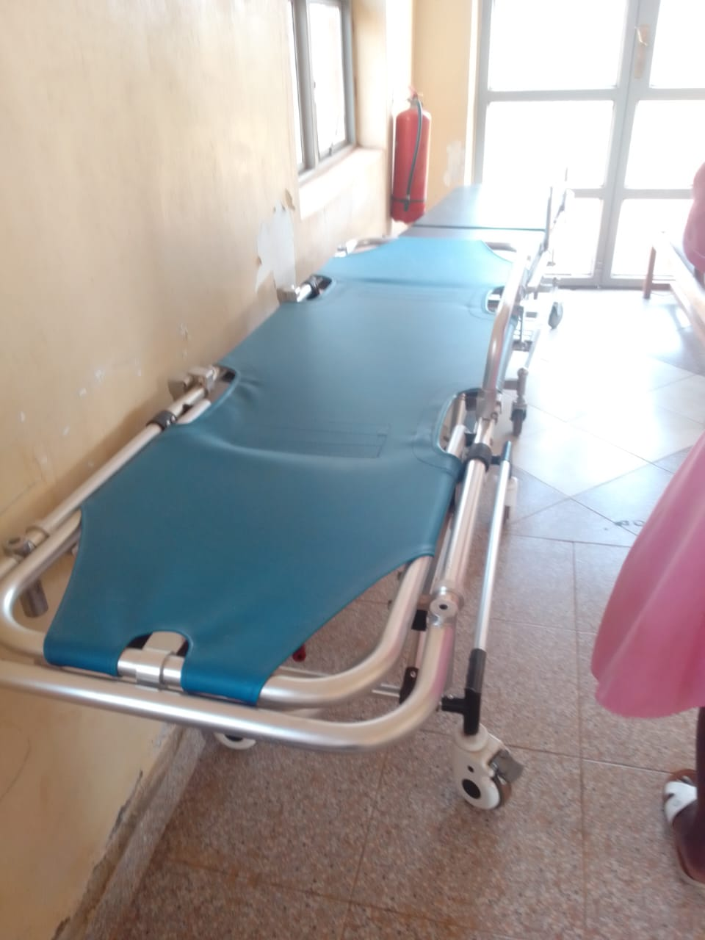
Spoilt office chair | 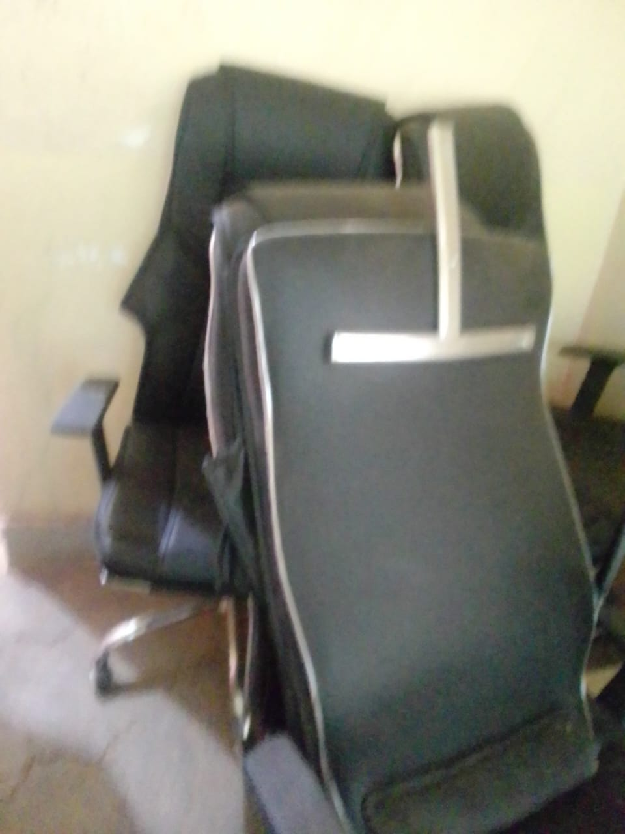
MATERNITY BUIL | 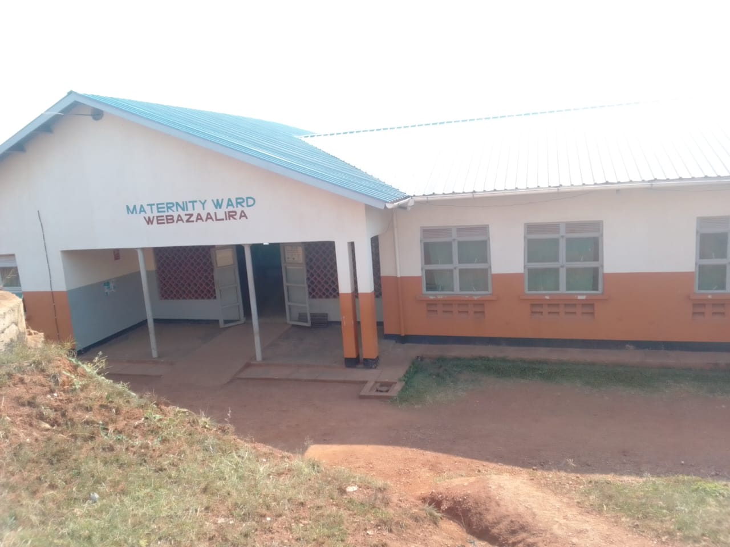
DING WITH A WASTE PIT AND A PLACENTA PIT | 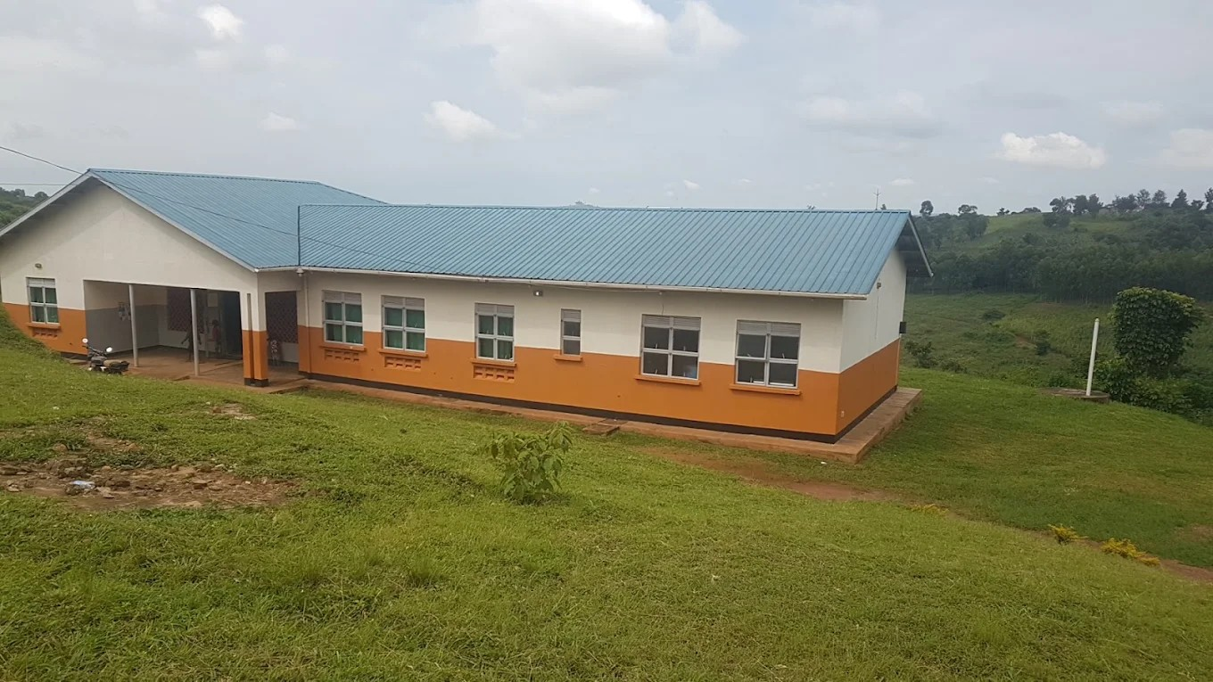
Sample of benches provided under UGIFT | 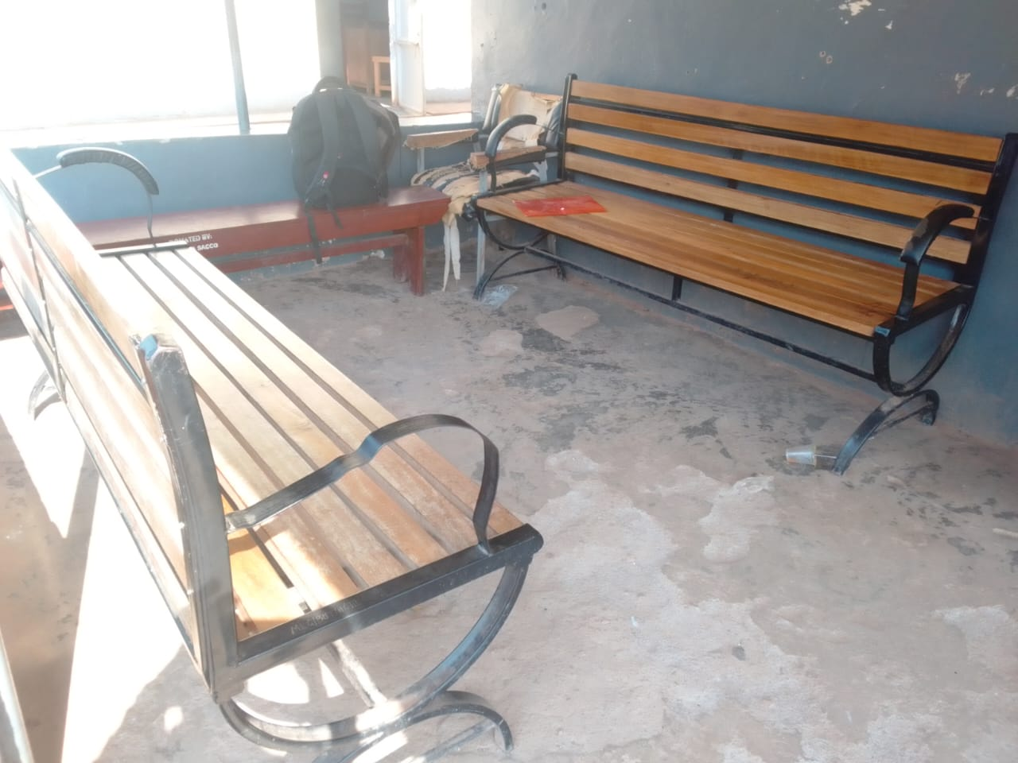
Sample of patient beds with drip stands. | 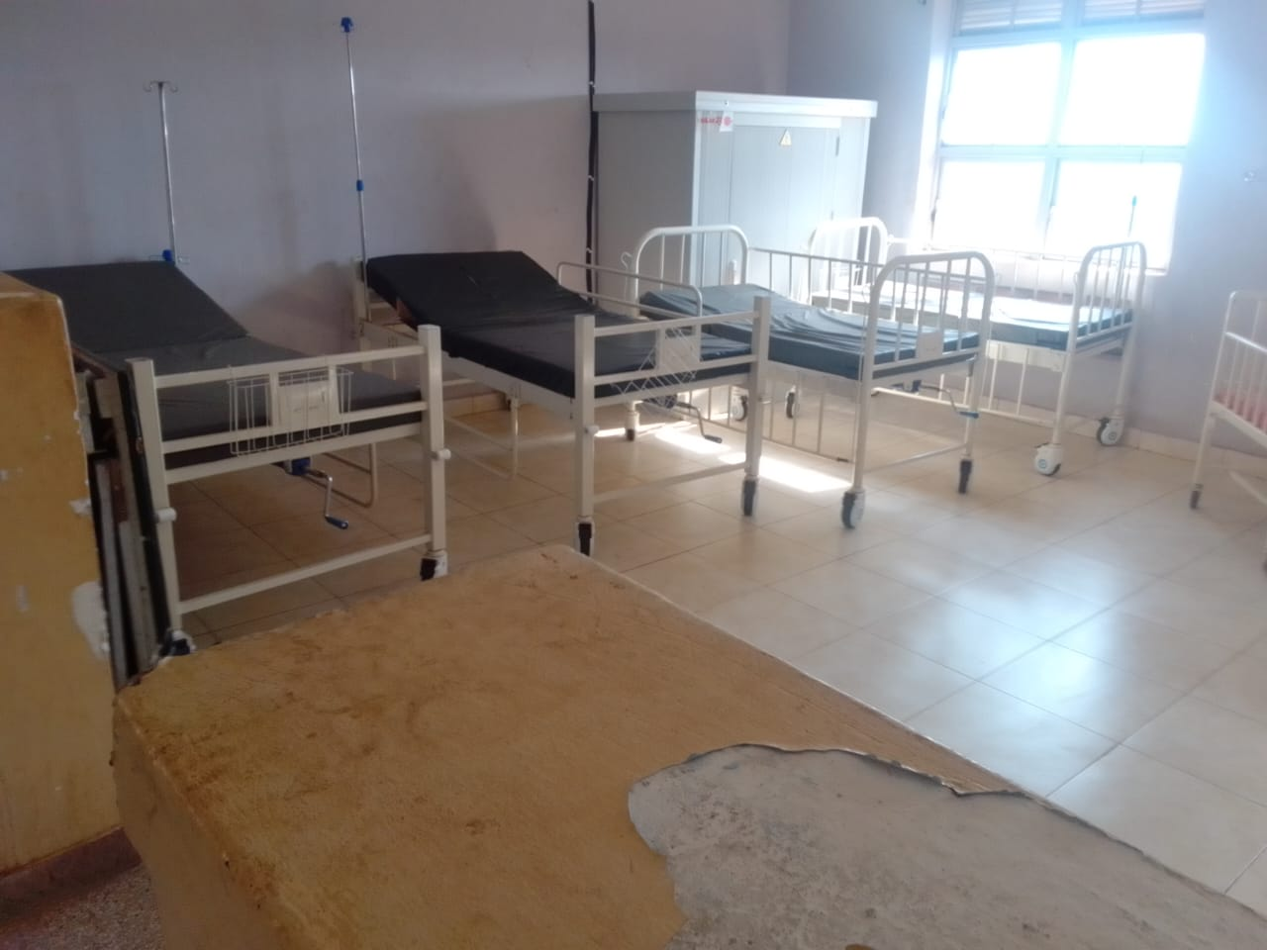  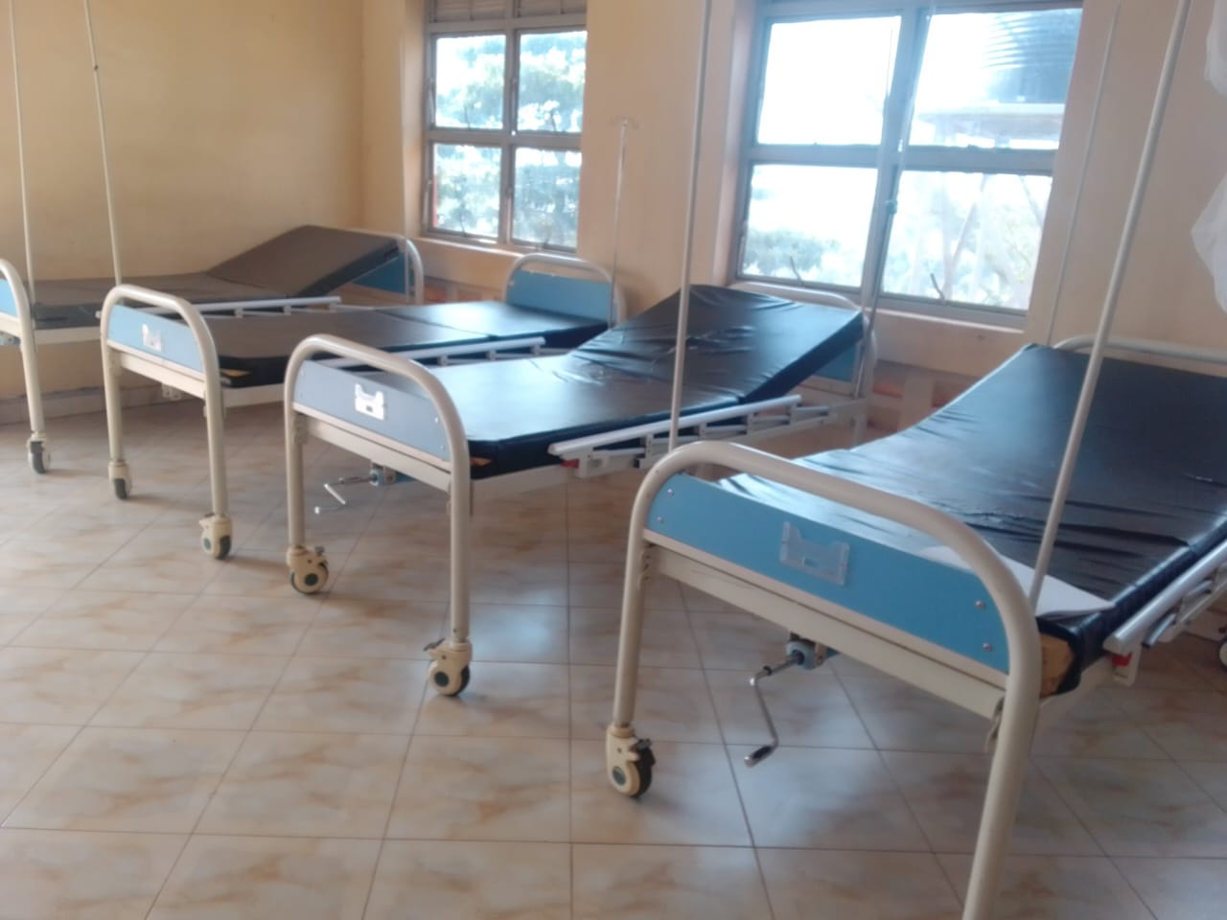
Sample of pediatric beds | 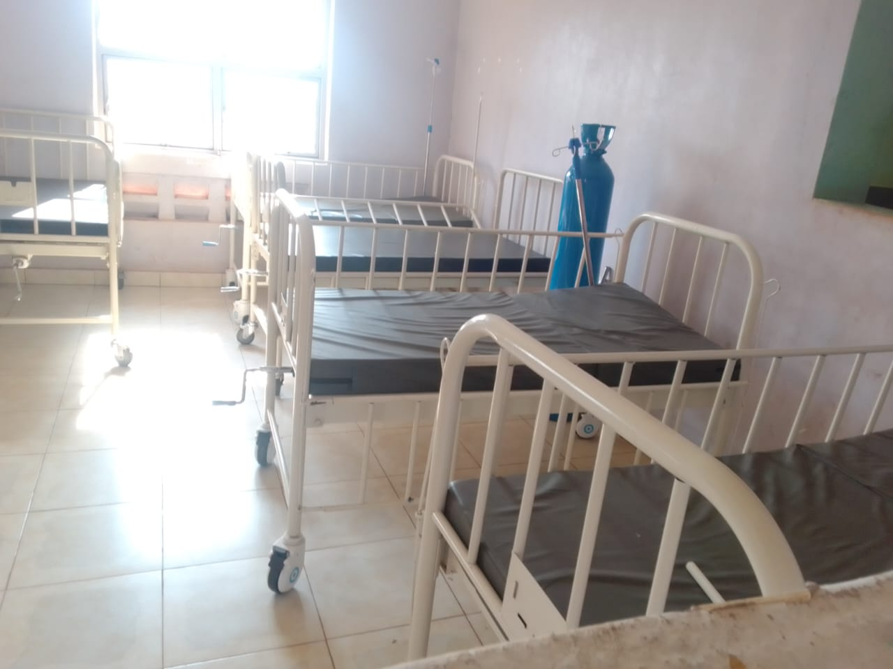
Bowl stand | 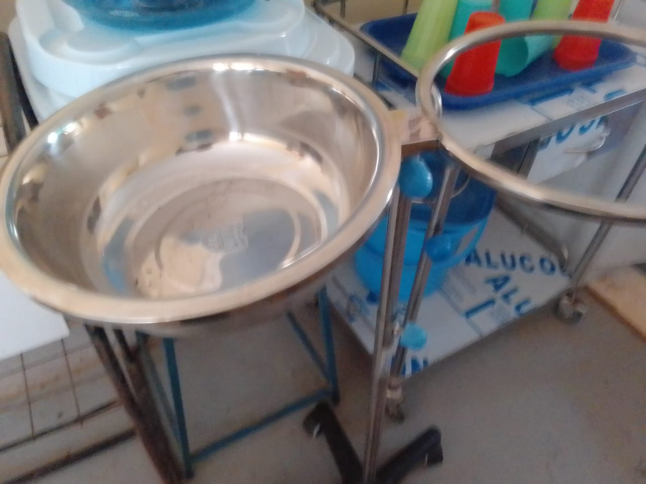
Office chair sample that’s faulty | 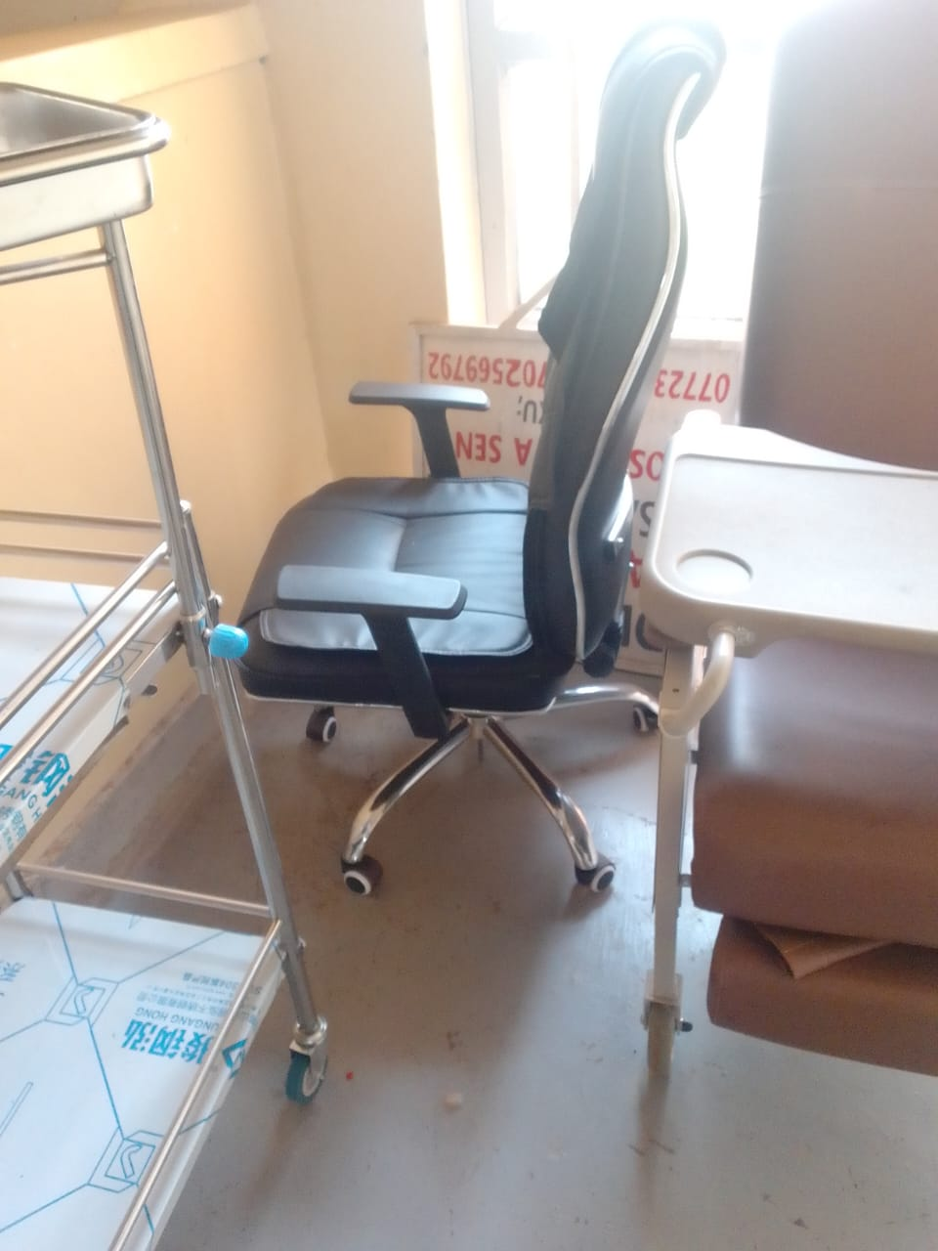
Examination couch | 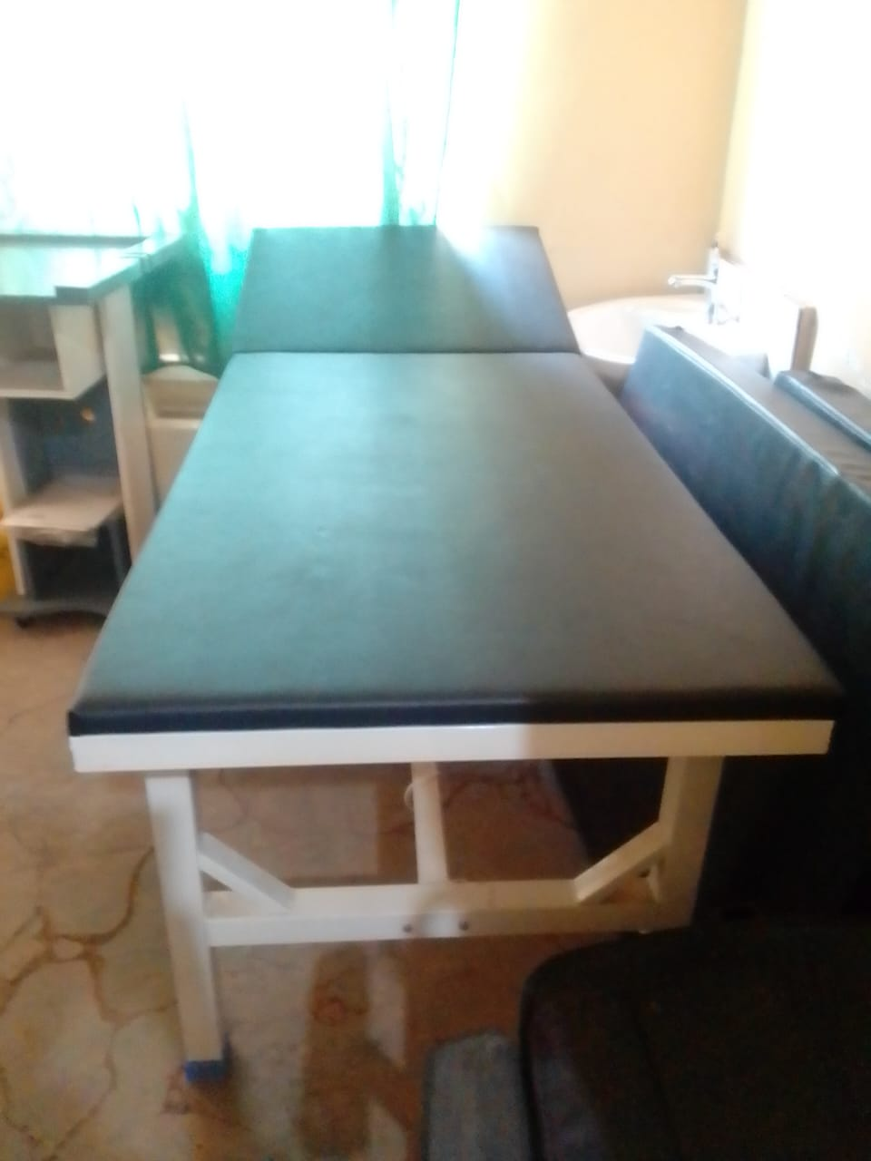
Delivery bed, hydraulic.  the staff have never used this bed because they don’t know how to operate it | 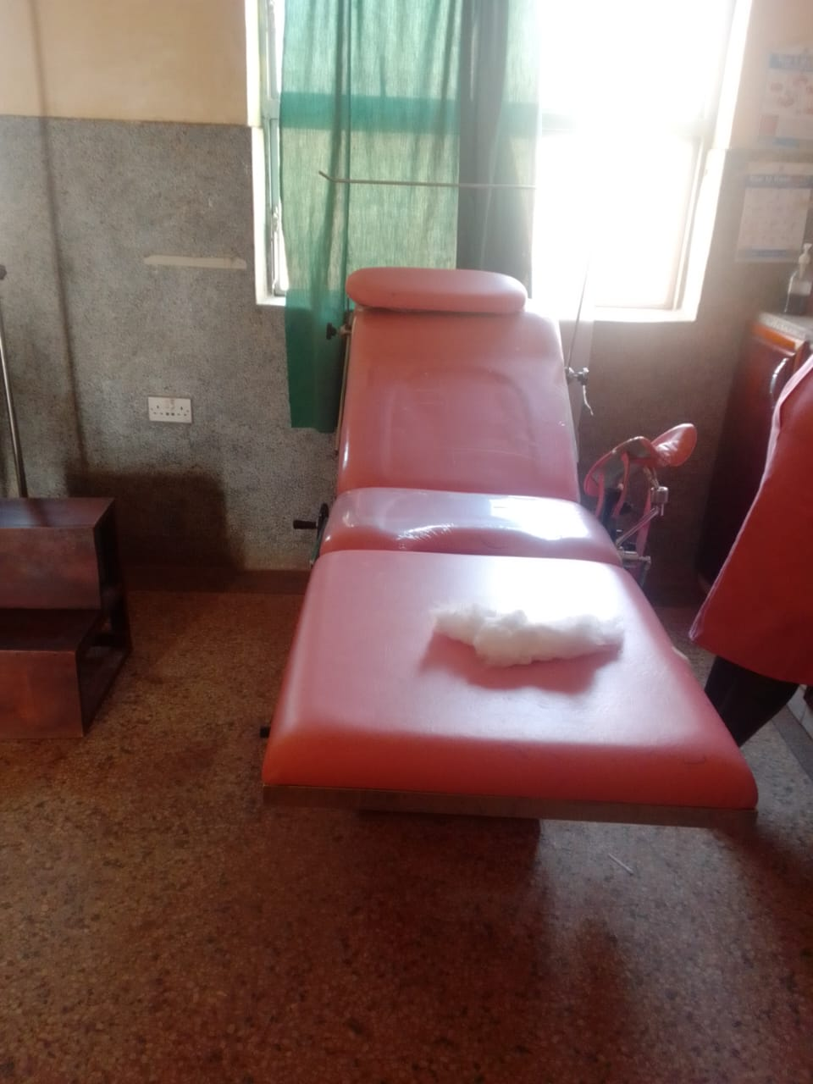
Delivery sets, MCH and instrument trolley | 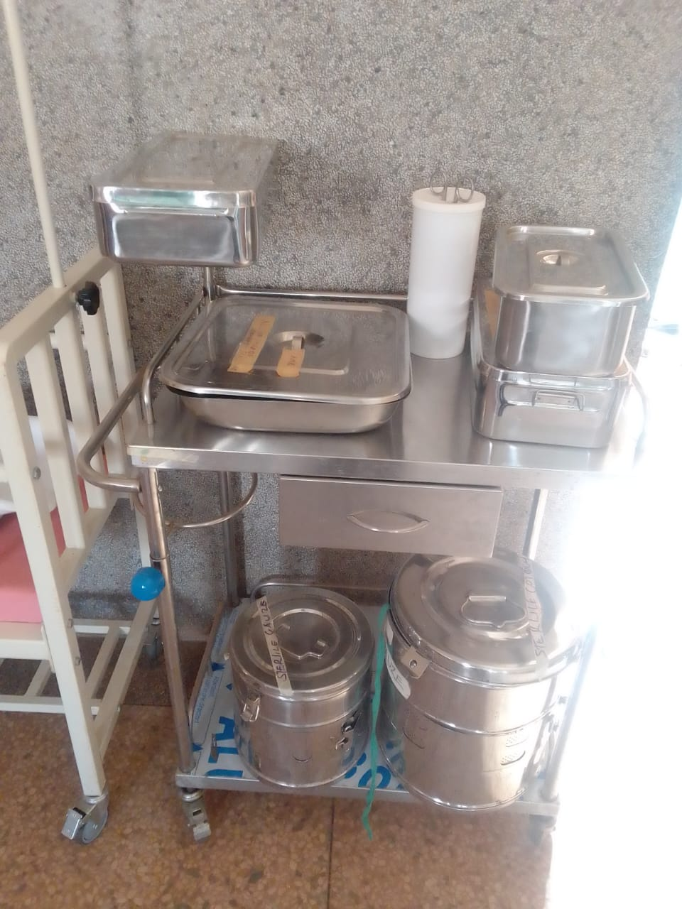
Examination light, LED and
Oxygen concentrator, its faulty and over heats
 | 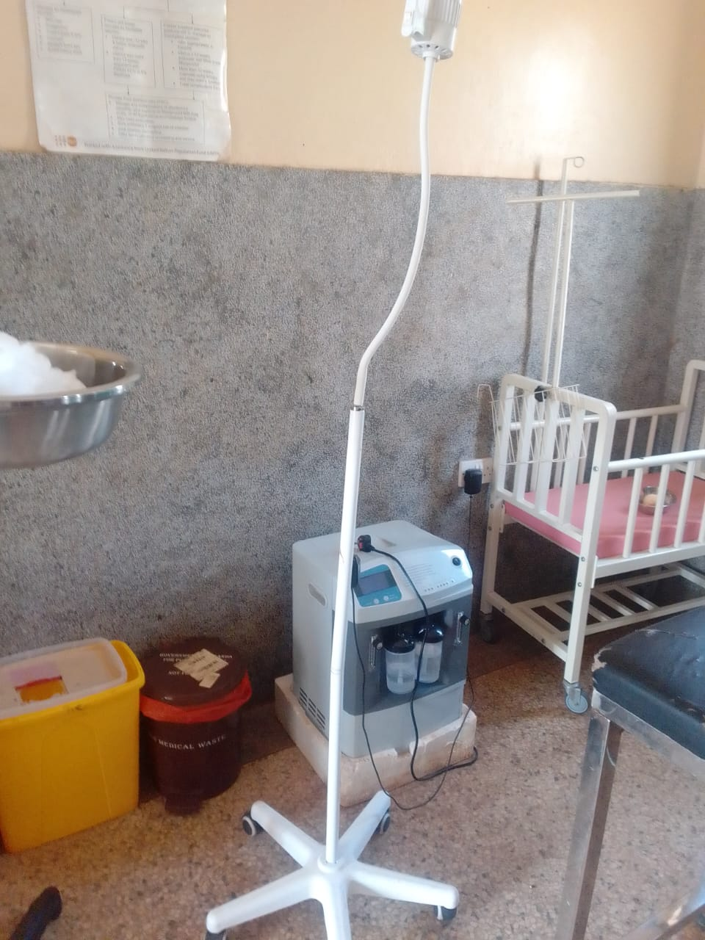
Bed side lockers, faulty sample | 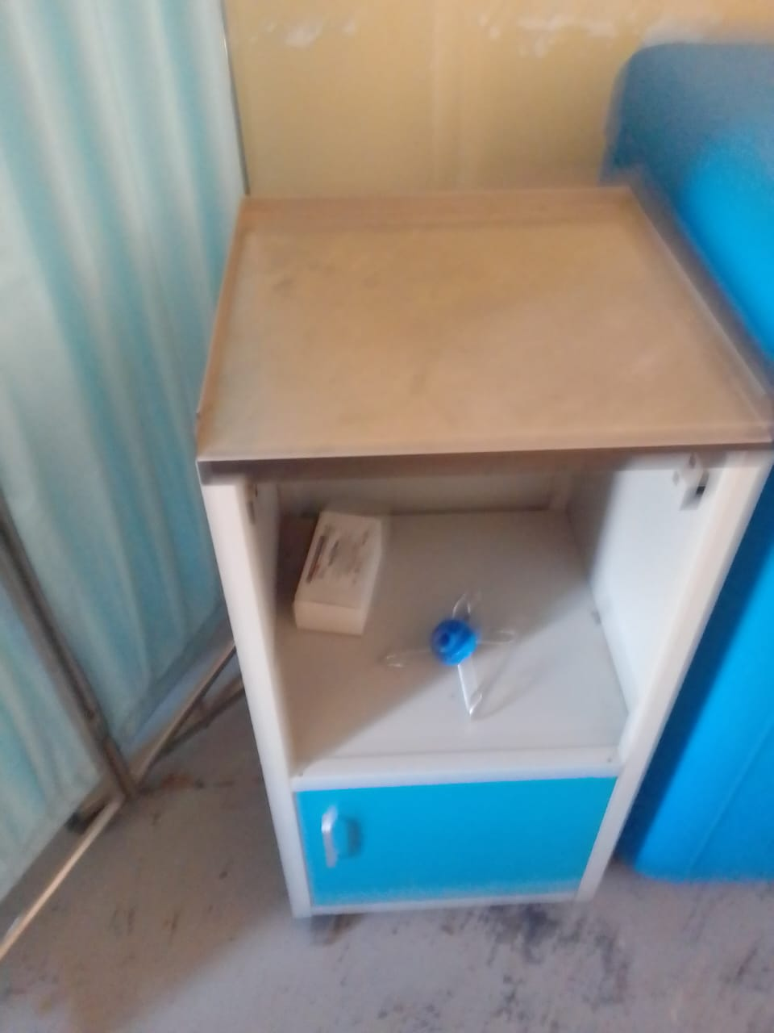
Sample of bay cots | 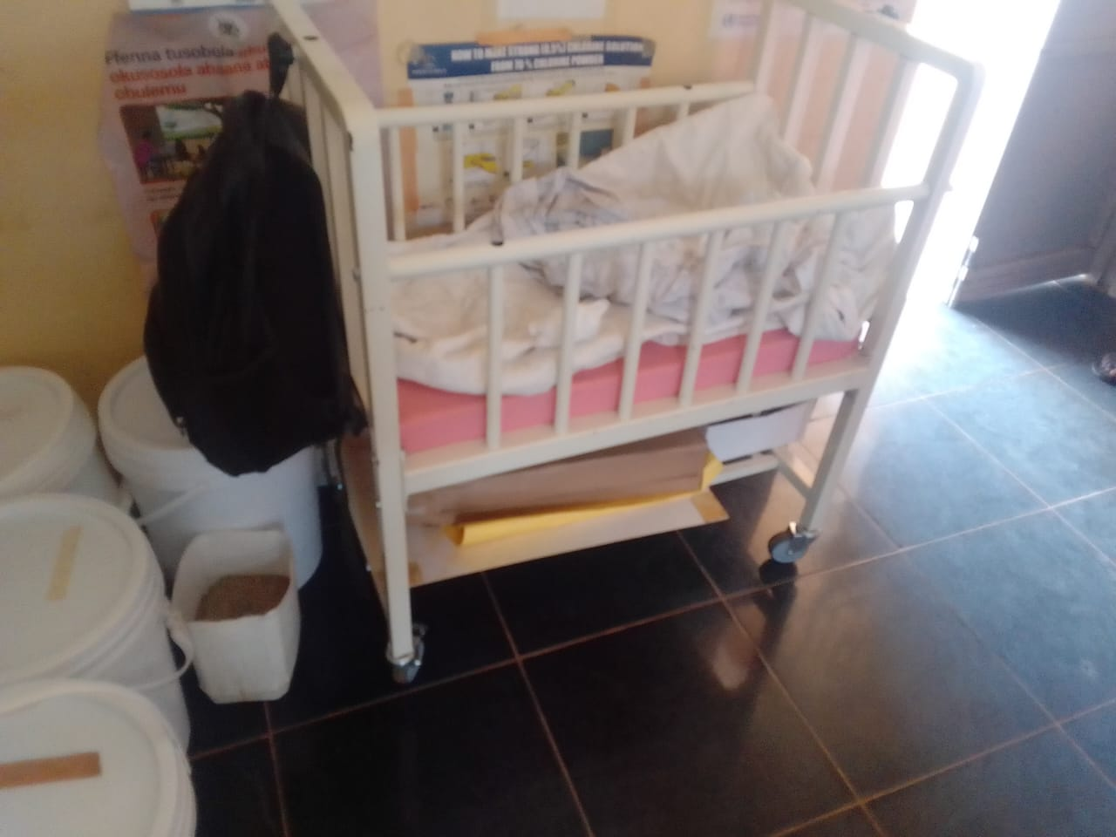
Cupboard with glass, still in its box | 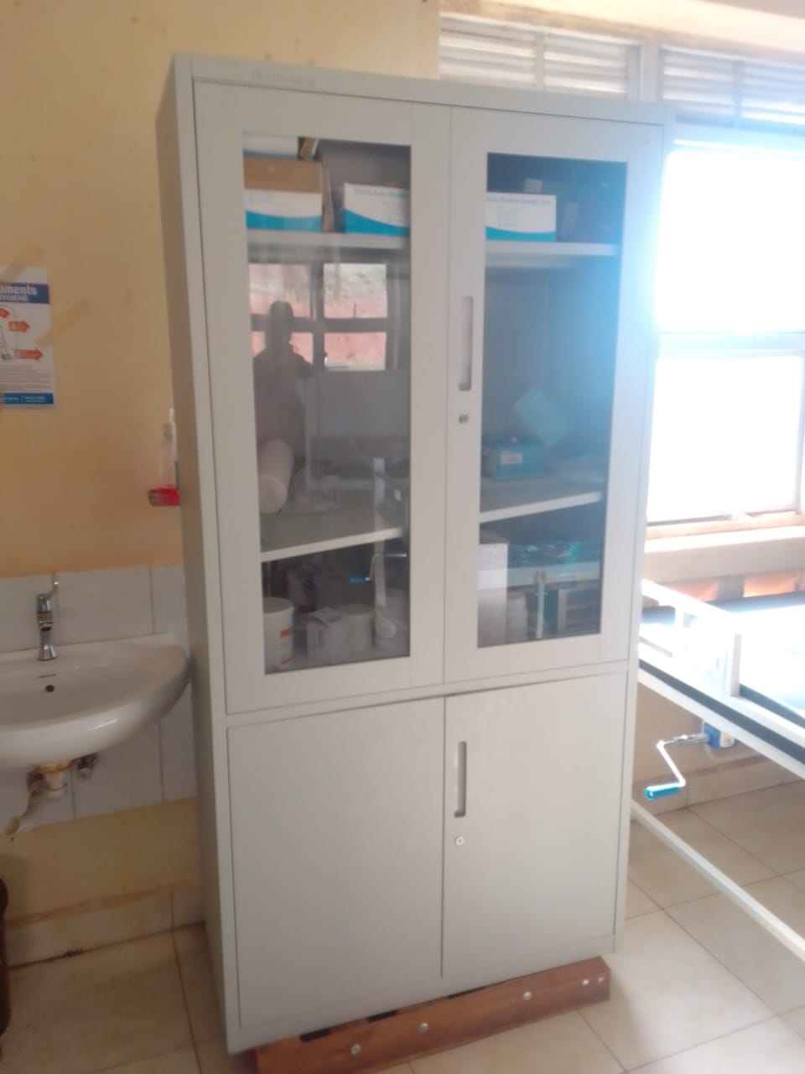
Weighing scale toddler, and other equipment packed in the baby cot | 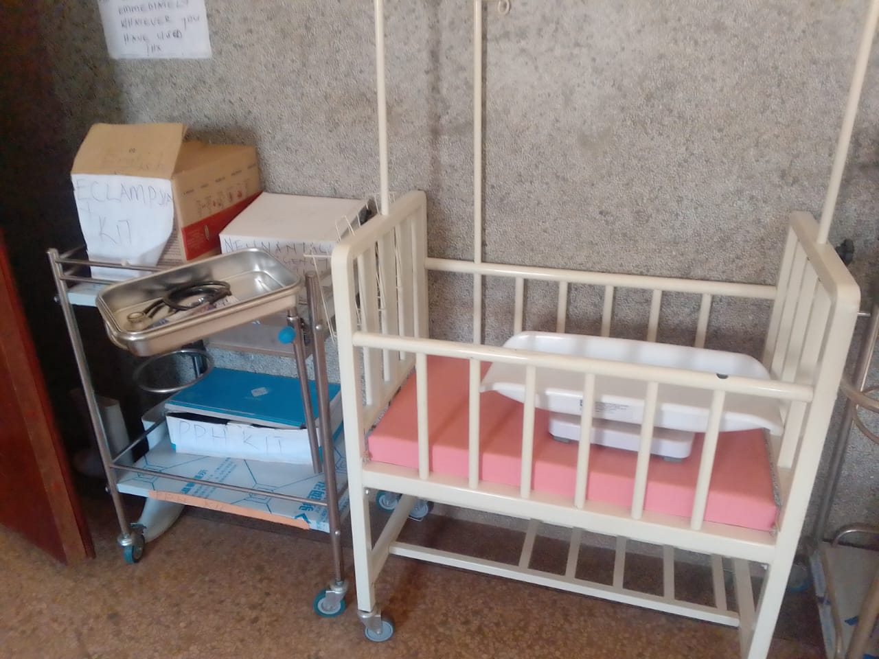
Sample weighing scale, adult with a height meter | 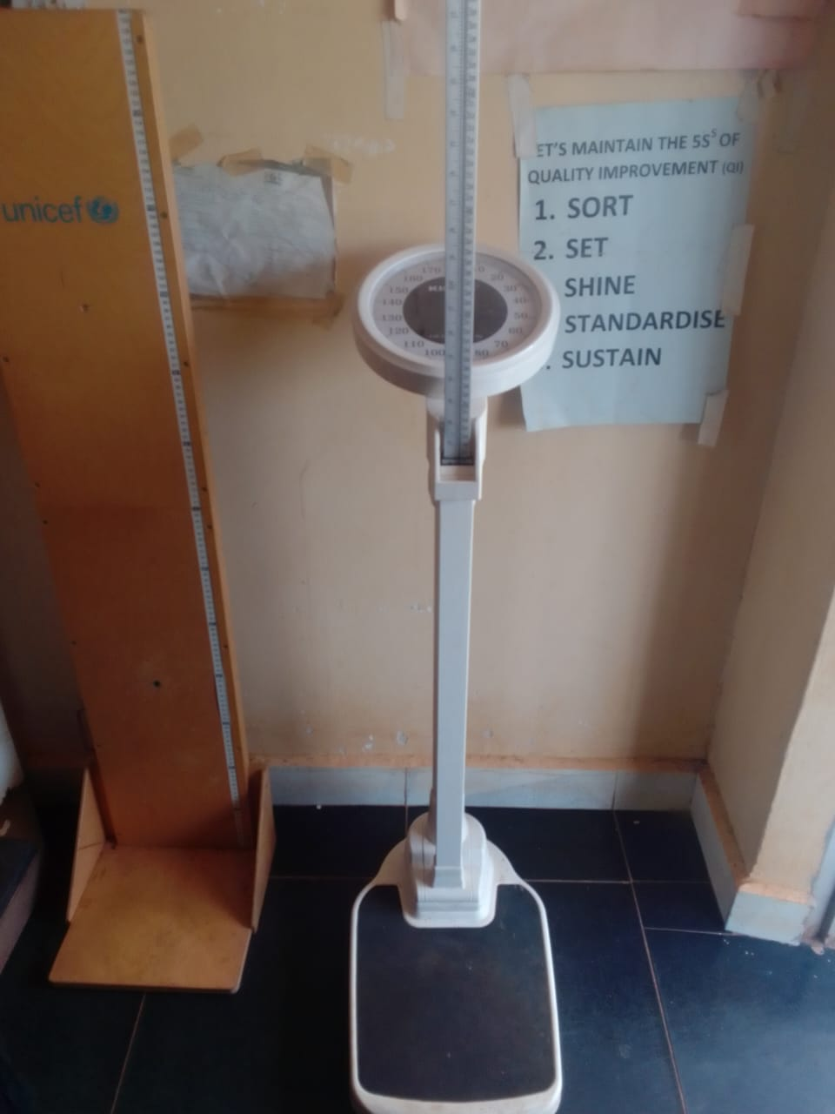
Oxygen apparatus | 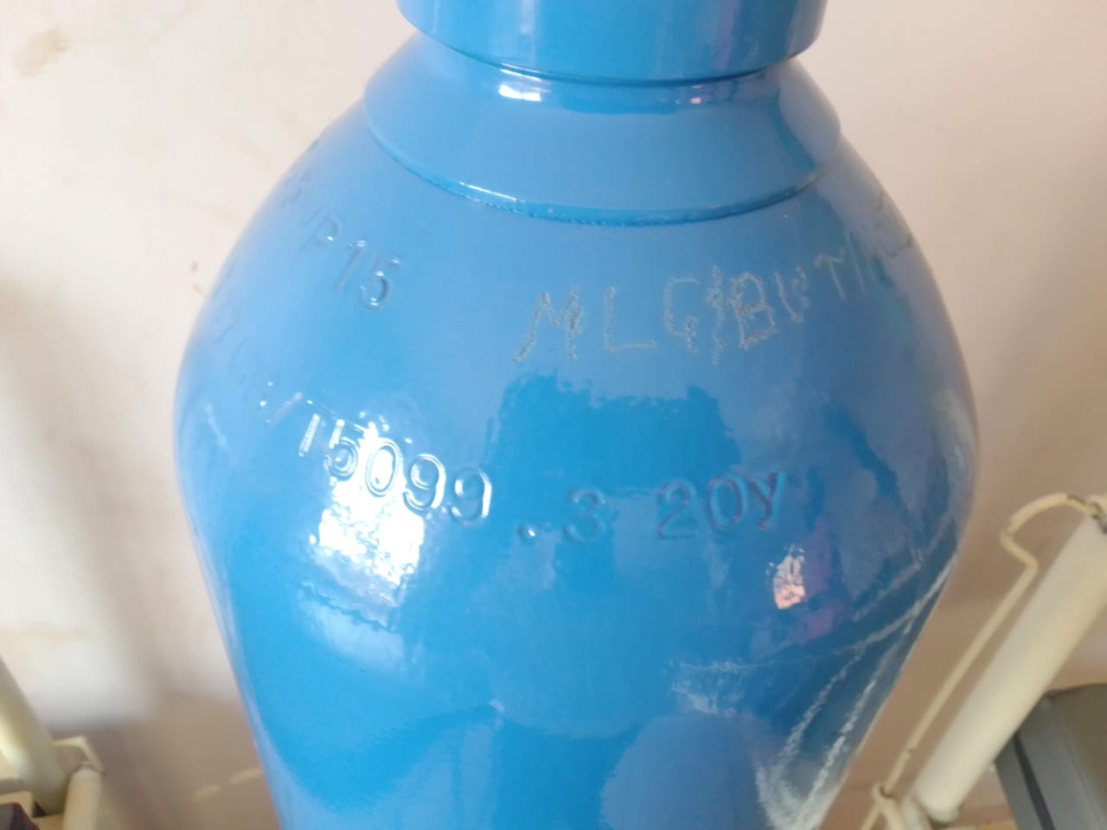
Cupboard metallic lockable | 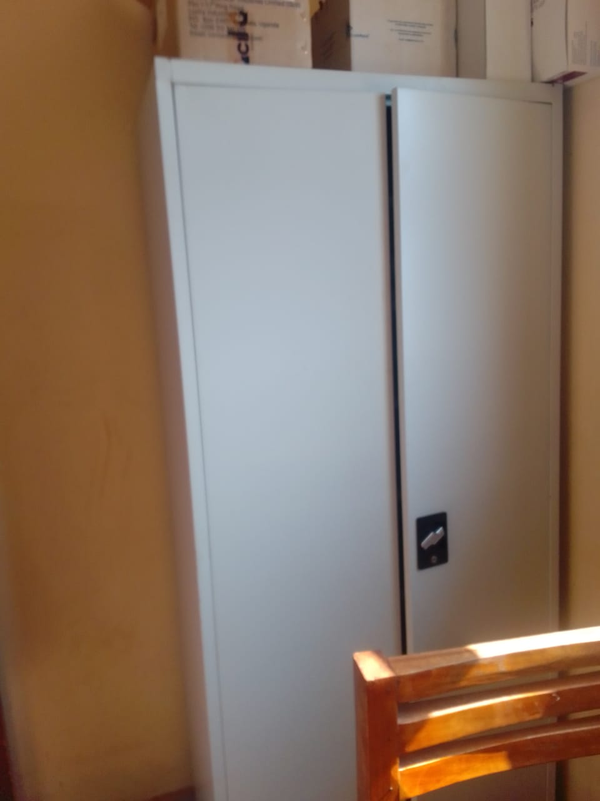
Sample of Stretcher, with drip stand | 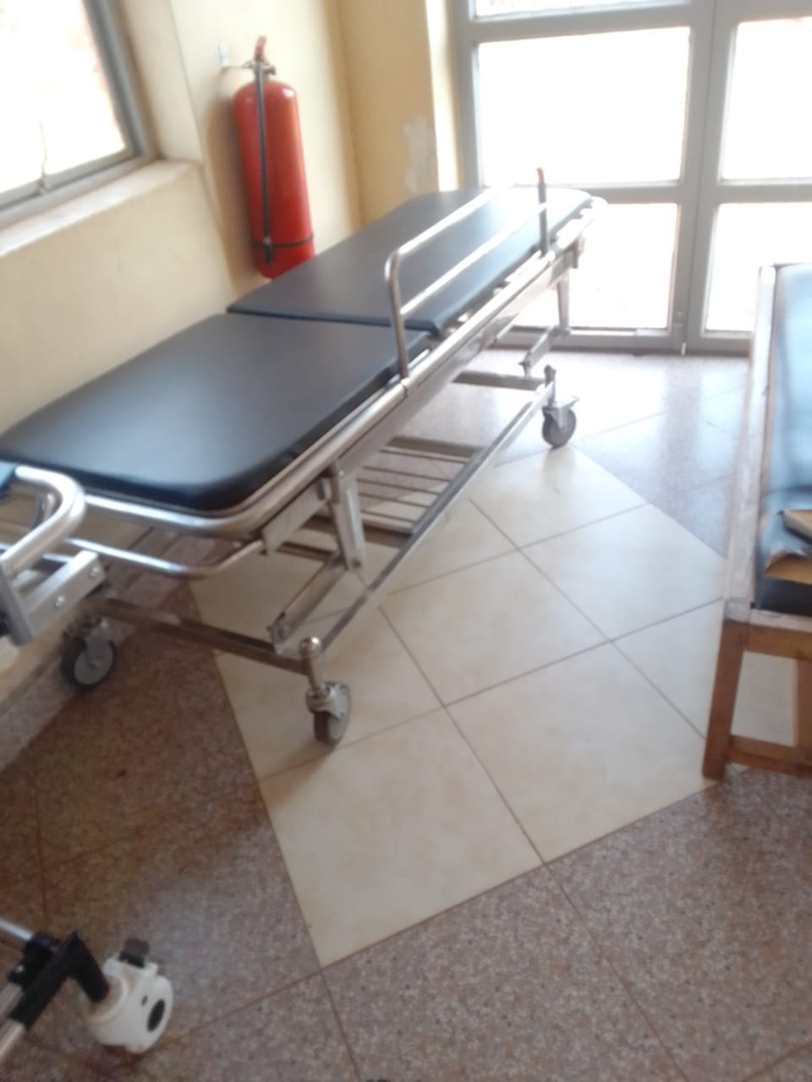
Sample of a wheelchair with a drip stand | 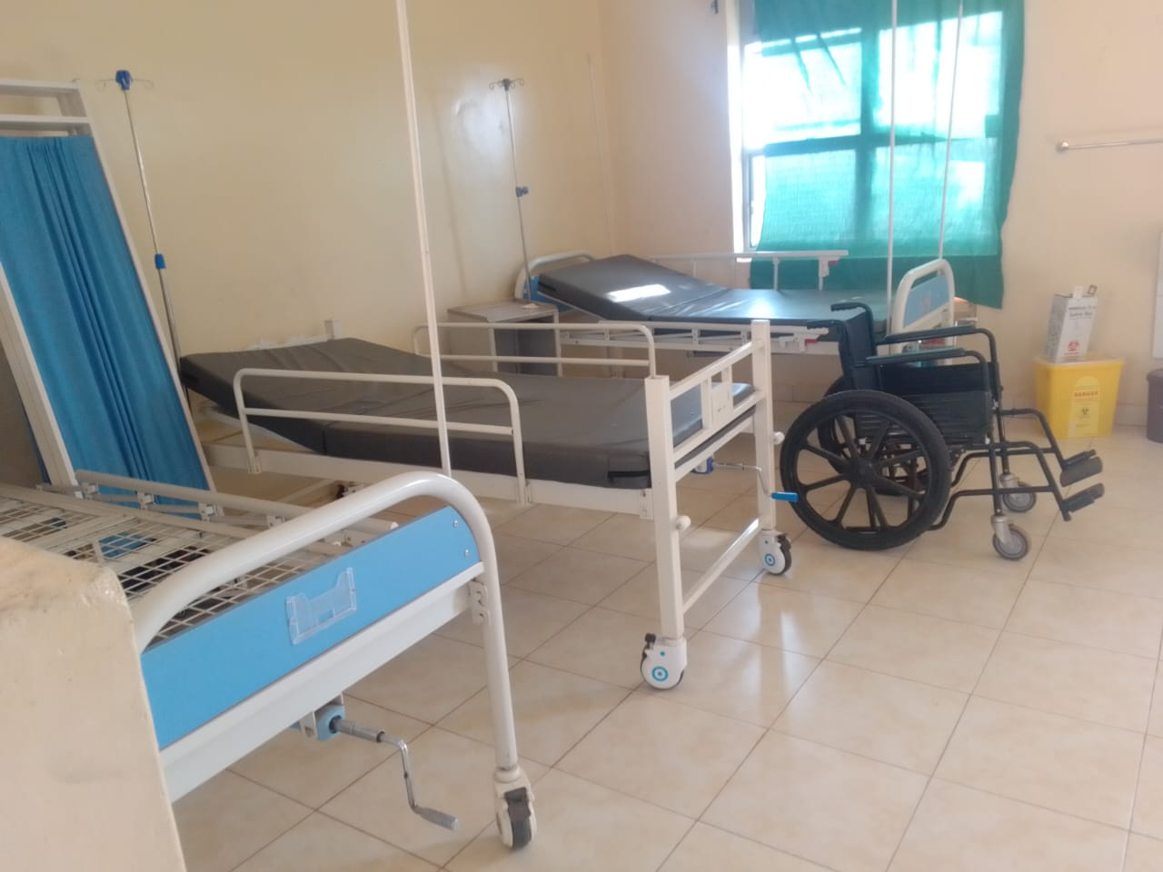
Newly supplied table from UGIFT, however they are all spoilt | 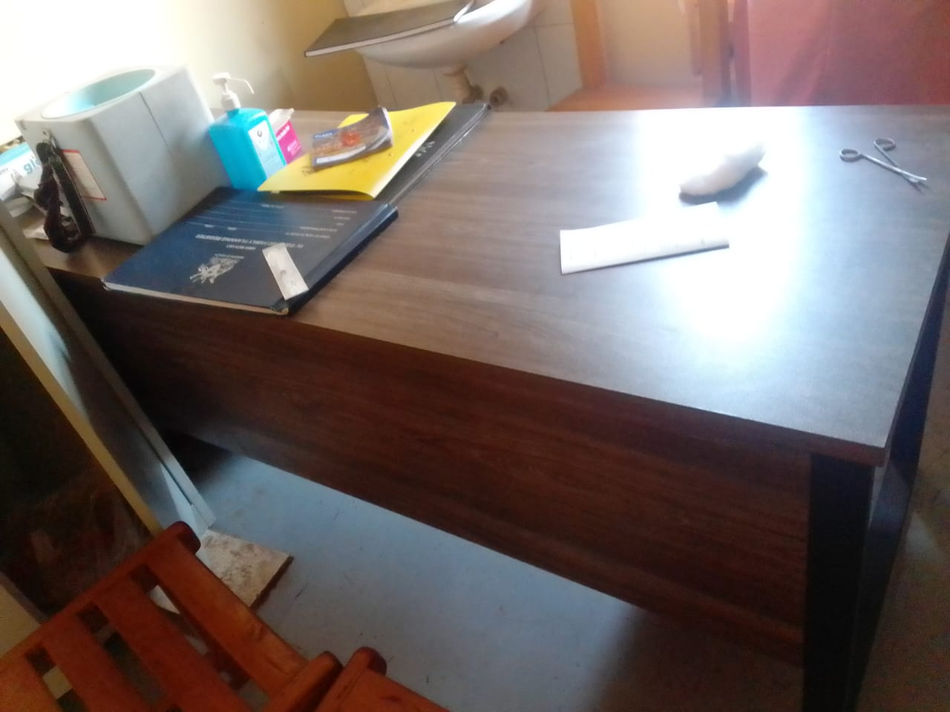
Kangaroo mother care chair still in the box | 